**Experiment 0**

**Aim:** Describe Breadboard and Multimeter.

**Apparatus:** Breadboard, Multimeter, resistances, led, 9v battery.

**Circuit Diagram:**

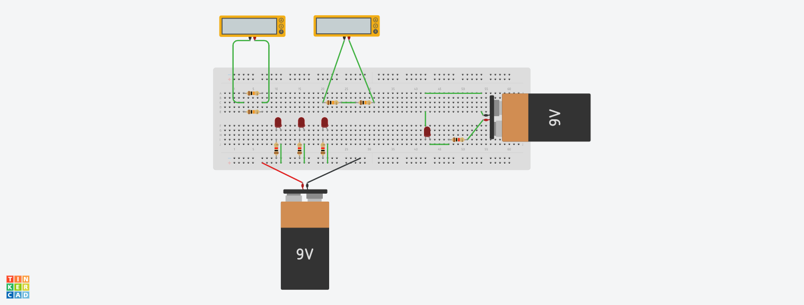

**Theory:**

1. Concept Used:
2. There are internal connections in breadboard in varying position.
3. Multimeter is used to measure resistance, current and voltage.
4. Led allows current to pass current only in one direction.
5. Learning & Observations:
6. Learn Basics of LED and identify cathode and anode of LED.
7. Circuit works only when p terminal of LED is connected to digital output pins and n terminal to GND.
8. In Arduino, digital pins are used to provide output to circuit.
9. LED may be damaged if we do not use resistance.

**Problems and Troubleshooting:**

1. Defining cathode and anode in any LED. It is solved by analyzing LED carefully.
2. Doing wrong connections in breadboard. It is solved by knowing more about breadboard.

**Precautions:**

1. Connections should be made carefully and clearly.
2. We should use resistance so that excess current may not damage any LED.
3. LED should be checked before using in circuit whether it is working or not.
4. Resistances should be properly connected in series and parallel to measure.

**Learning Outcomes:**

1. Using the Breadboard and how connections are made inside a breadboard.
2. Join different components of circuit like LED, Resistance in proper way.
3. We should use resistance of a certain value only.
4. Giving connections to led using 9v battery.

**Result:** Breadboard and Multimeter are described.